Marijuana Anonymous Convention 2018
“Living in Gratitude”
February 16–18, 2018, Seattle, Washington
Crowne Plaza – Seattle Airport

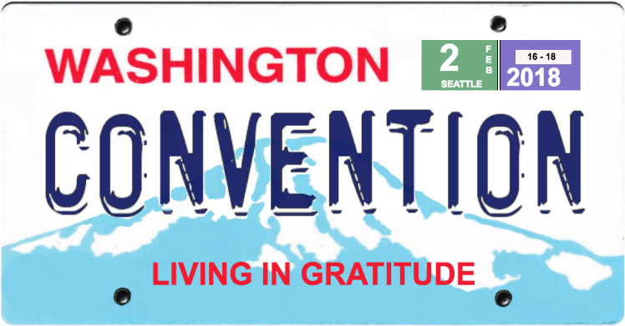

Make your plans now to attend Marijuana Anonymous Convention 2018, hosted by District 4 in Seattle.
A reduced-price “early-bird event registration” rate is available now through October 31, 2017. Crowne Plaza – Seattle Airport is offering great lodging rates, so book early. In addition, a registration raffle is running this month, August 2017. You may also make donations for scholarships or operating expenses.
Conventions are events where we come together to celebrate our recovery in Marijuana Anonymous and enjoy the fellowship of other recovering marijuana addicts. The theme of the 2018 Convention is “Living in Gratitude”. Some of the main features of the Convention are topic panels and step workshops, speaker meetings, a banquet and entertainment.

For MA Convention 2018 registration, to book lodging or to donate: mawsconvention.org

For questions or to contact Convention 2018 Host Committee: convention@madistrict4.org

